**Sprint** 3 **-** Agility **Design Document**

November 29**, 20**22

**Table of Contents**

**1.** **EXECUTIVE SUMMARY 3**

1.1 Project Overview 3

1.2 Purpose and Scope of this Specification 3

**2.** **PRODUCT/SERVICE DESCRIPTION 3**

2.1 Product Context 3

2.2 User Characteristics 3

2.3 Assumptions 3

2.4 Constraints 3

2.5 Dependencies 4

**3.** **REQUIREMENTS 4**

3.1 Functional Requirements 5

3.2 Security 5

*3.2.1* *Protection 5*

*3.2.2* *Authorization and Authentication 6*

3.3 Portability 6

**4.** **REQUIREMENTS CONFIRMATION/STAKEHOLDER SIGN-OFF 6**

**5.** **SYSTEM DESIGN 6**

5.1 Algorithm 6

5.2 System Flow 6

5.3 Software 6

5.4 Hardware 6

5.5 Test Plan 7

5.6 Task List/Gantt Chart 7

5.7 Staffing Plan 7

# Executive Summary

## ***Project Overview***

The robot will travel in a zigzag across the blue tape, avoiding the glass bottles, successfully going up and over the ramp, and hitting as many of the marker pins as possible.

## ***Purpose and Scope of this Specification***

The purpose of this project is to successfully have the robot travel in a zigzag across the blue tape - avoiding the glass bottles, over the binder ramp, and turning in a straight line into the markers.

**In scope**

* Sphero follows the blue tape around the obstacles
* Sphero travels up and over the ramp
* Sphero knocks over as many pins as it can

**Out of Scope**

The following are out of scope:

* When the sphero does not follow the blue tape and hits the obstacles
* When the sphero does not make it up the ramp
* When the sphero does not knock over any pins

# Product/Service Description

* This project is for Intro to Problem Solving (CS 104-01)
* This Sprint of the project is due November 29, 2022

## ***Product Context***

* Independent; one part of triathlon
* 3 group members working on the same project
* Connected to a larger project but the part is independent

## ***User Characteristics***

* Students in CS 104-01
* 2 or fewer years of computing experience
* First time using Sphero Application

## ***Assumptions***

The robot is assumed to work as needed. Howard Hall Room 208 is assumed to be available when needed. The block code is assumed to work as needed. Team members are assumed to be available at the same times.

## ***Constraints***

Describe any items that will constrain the design options, including

* Operation of the robots
* Functionality of the robot
* Access to Howard Hall Room 208
* The Sphero Application
* Tape on the ground

***2.5 Dependencies***

List dependencies that affect the requirements:

* Must be in Howard Hall Room 208
* Must use the Sphero Application to control the robot

# Requirements

## ***Functional Requirements***

For Example:

| **Req#** | **Requirement** | **Comments** | **Priority** | **Date Rvwd** | **SME Reviewed / Approved** |
| --- | --- | --- | --- | --- | --- |
| AGILITY_01 | Robot follows blue tape through agility course | Most important to get correct. | 1 | 11/16 | Lola Weis |
| AGILITY_02 | Robot accurately navigates through the glass bottles while following tape | Necessary for full credit, but not as important as getting the overall shape correct | 2 | 11/16 | Lola Weis |
| AGILITY_03 | Robot rolls up the binder and jumps off back onto the blue tape. | Necessary for full credit and easy to add once the first and second priorities are met. | 3 | 11/16 | Lola Weis |
| AGILITY_04 | Robot knocks down as many pins (markers) as possible and stops. | Necessary for full credit and easy to add once the first, second, and third requirements are met. | 4 | 11/16 | Lola Weis |

## 

***Security***

There is a password to get onto the computer that contains the code for the Robot.

### **Protection**

* A sphero account and password
* Authentication checks
* Github account and password

### **Authorization and Authentication**

* You need a Sphero account with an email that has been authenticated.

## ***Portability***

* Code is entirely host dependent
* It uses Sphero block code
* The Sphero application can be used on both computers and mobile telephones

# Requirements Confirmation/Stakeholder sign-off

Include documentation of the approval or confirmation of the requirements here. For example:

| **Meeting Date** | **Attendees (name and role)** | **Comments** |
| --- | --- | --- |
| 11/15/2022 | Lola, Ty, Baylor | Achieved Requirements 1 and 2, confirmed |
| 11/16/2022 | Lola, Ty, Baylor | Achieved Requirements 3 and 4, confirmed |

# System Design

This section will provide all details concerning the technical design, staffing, coding, and testing the system

## ***Algorithm***

1. Start in the square
2. The robot will travel forward avoiding the glass bottle
3. The robot will turn and travel forward avoiding the glass bottle
4. The robot will turn and travel forward avoiding the glass bottle
5. The robot will turn and go over the ramp and continue to travel until it reaches the corner of the blue tape
6. The robot will turn and continue straight
7. The robot will knock over as many markers as possible

## ***System Flow***

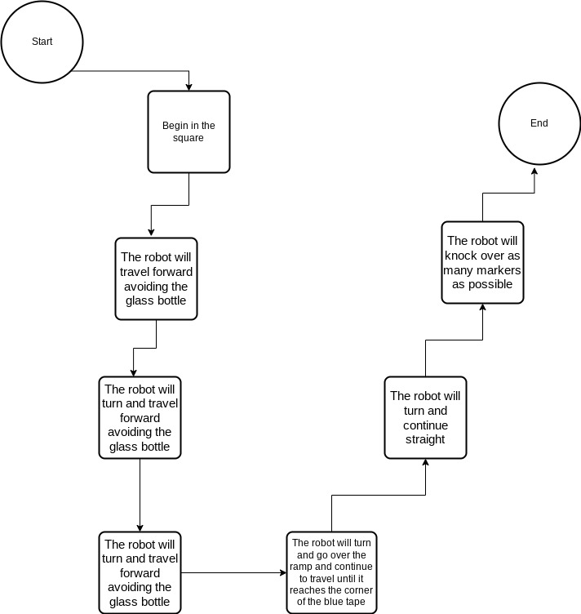

## ***Software***

Sphero block code, Sphero application, Github website

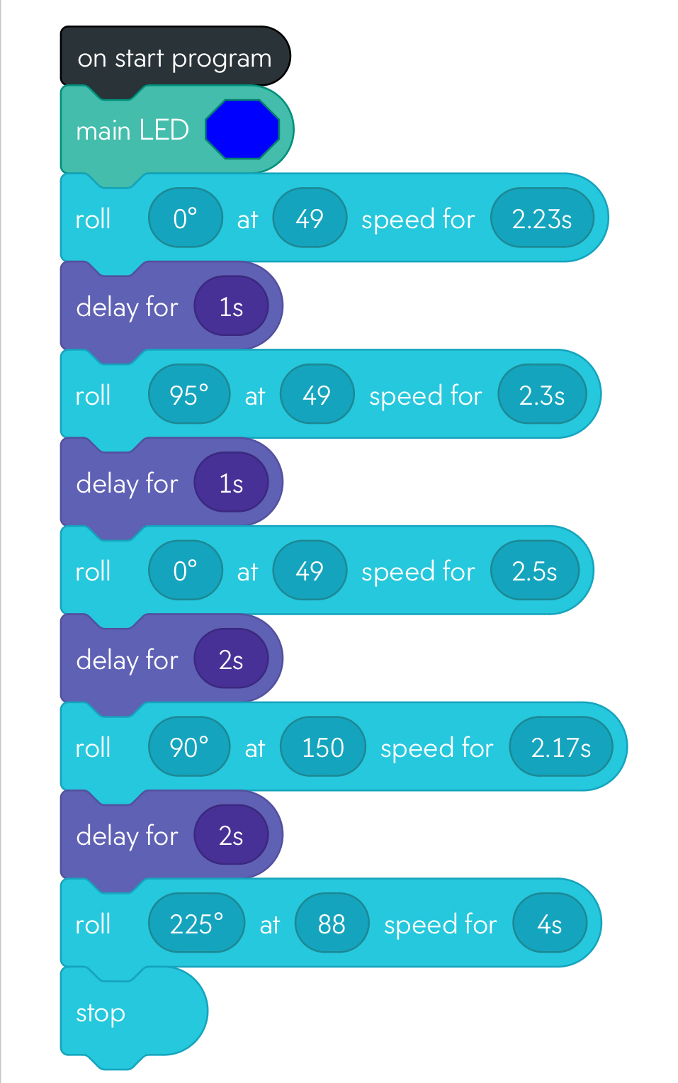

## ***Hardware***

Computer, Iphone, Sphero Spark Robot, Bluetooth

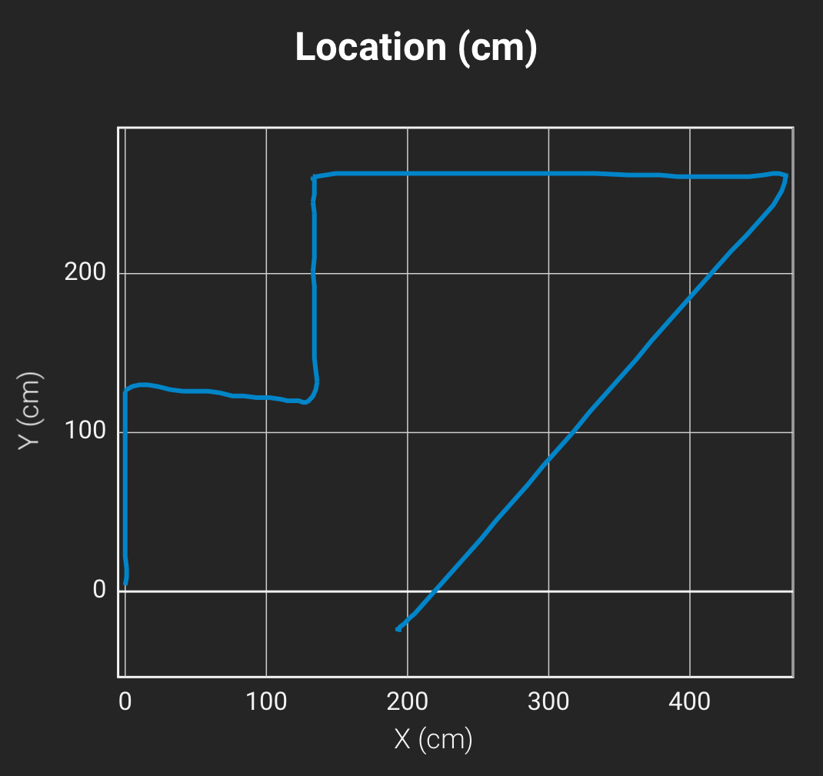

## ***Test Plan***

Include a test plan showing all unit tests performed for this application, Include test rational, test date, staff member, pass/fail status

| **Reason for Test Case** | **Test Date** | **Expected Output** | **Observed Output** | **Staff Name** | **Pass/Fail** |
| --- | --- | --- | --- | --- | --- |
| Align aim to go to first jar | 11/15 | to go straight | did go straight | Ty | pass |
| Diagonal to second jar | 11/15 | to stop perfectly by second jar | stopped by second jar | baylor | pass |
| distance to third jar | 11/15 | to stop perfectly by third jar | was short of the third jar | baylor | fail |
| distance to third jar | 11/15 | to stop perfectly by third jar | was short of the third jar | lola | fail |
| distance to third jar | 11/15 | to stop perfectly by third jar | Overran the third jar | ty | fail |
| Distance to third jar | 11/15 | to stop perfectly by third jar | stopped by third jar perfectly | baylor | pass |
| Go over binder | 11/16 | Go over binder and stop at corner | speed was not fast enough | lola | fail |
| Go over binder | 11/16 | Go over binder and stop at corner | went over binder but overshot the corner | ty | fail |
| Go over binder | 11/16 | Go over binder and stop at corner | Went over binder and hit the corner perfectly | baylor | pass |
| to hit the markers | 11/16 | to hit the markers | Was short of the markers | lola | fail |
| to hit the markers | 11/16 | To hit the markers | Hit the markers at the end | ty | pass |

## ***Task List/Gantt Chart***

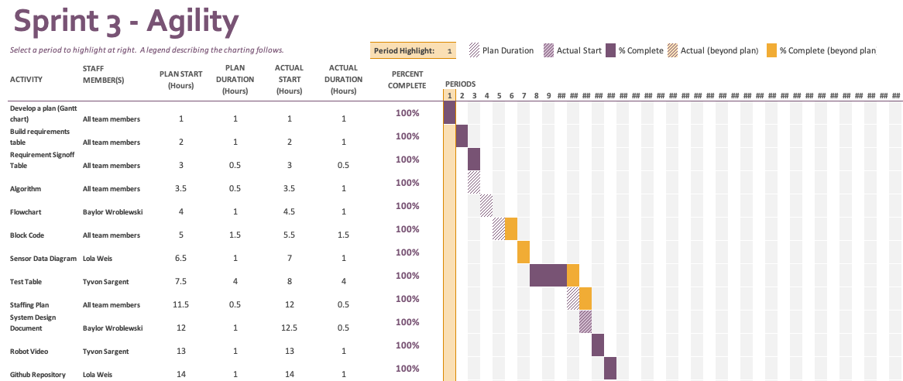

## ***Staffing Plan***

Insert a chart/table that depicts the roles and responsibilities of each team member that worked on this project

| Name | Role | Responsibility | Reports To |
| --- | --- | --- | --- |
| Baylor Wroblewski | Tech Coordinator | Coder, Robot owner | Lola |
| Lola Weis | Planner, Organizer | Gantt chart, Github owner | Tyvon |
| Tyvon Ali Sargent | Tester | Videographer, Test planner | Baylor |